**HARSHTON JUNIOR SCHOOL – MBALE**

**TERM ONE HOLIDAY PACKAGE-2023**

**P. 3 MATHEMATICS**

**Pupil’s Name: …………………………………………………………….**

|  |  |  |
| --- | --- | --- |
| **Qn. No.** | **MARKS** | **EXRS No.** |
| **1 – 5** |  |  |
| **6 – 10** |  |  |
| **11 – 15** |  |  |
| **16 – 20** |  |  |
| **21 – 22** |  |  |
| **23 – 24** |  |  |
| **25 – 26** |  |  |
| **27 – 28** |  |  |
| **29 – 30** |  |  |
| **31 – 32** |  |  |
| **TOTAL** |  |  |

**TURN OVER**

**Read the following instructions carefully:**

1. This paper has **two** sections **A** and **B**

Section A has **20** questions and Section **B** has **12** questions. The paper has 15 printed pages.

1. All the working for both sections A and B must be shown in the spaces provided.
2. All working must be done using a blue or black ball point pen or ink. Any work done in pencil other than graphs and diagrams will **not** be marked.
3. **No calculators** are allowed in the examination room.
4. Unnecessary changes of work may lead to **loss** of marks.
5. Any **handwriting** that cannot easily be read may lead to loss of marks.
6. Do not fill anything in the boxes indicated: “**For examiners’ Use only”** and those inside the questions paper.

`

**SECTION A (40 MARKS)**

|  |  |  |  |
| --- | --- | --- | --- |
| 1. | Work out: 1 3  + 1 4 | 2. | Write **23** in words. |
| 3. | Set P= {1, 3, 5, 7, 9}. How many members has set p? | 4. | Work out:  +  = |
| 5. | Fill in the missing numbers:  10, 20, 30, 40, _______, 60. | 6. | In the space below, Draw a cone. |
| 7. | Shade   |  |  |  |  |  | | --- | --- | --- | --- | --- | |  |  |  |  |  | | 8. | What is the place value of **7** in **672**? |
| 9. | One table has 4 legs. How many legs do 3 tables have? | 10. | How many circles can you see? |
| 11. | Complete correctly.  843 = _________ hundreds ________ tens _________ones. | 12. | Write the set symbol for an empty set. |
| 13. | What number has been shown on the abacus?  H T O | 14. | Fill in the missing number.  + 3 = 7 |
| 15. | What is the time shown on the clock face?    It is _______________ o’clock. | 16. | What number comes after **20.** |
| 17. | Circle the smallest number  3 2 2 3 2 3 | 18. | Allan had 12 goats. 4 goats died. How many goats remained? |
| 19. | Divide 3 36 | 20. | What is the first day of the week? |

**SECTION B (60 MARKS)**

1. Draw these shapes.

|  |  |  |
| --- | --- | --- |
| **Triangle** | **Circle** | **Cone** |
|  |  |  |

1. Work out:
2. 2 4 2 b) 9 4 2

+ 1 3 5 - 1 3 1

1. 24 ÷ 6 =
2. Describe the shaded regions on the venn diagrams below.
3. A B ii) K Q
4. Shade PuQ

P Q

1. Complete the following statements below using +, – x or ÷.
2. 5 __________ 4 = 1
3. 3 ___________ 3 = 6
4. 8 ___________ 4 = 2
5. 2 ___________ 3 = 6
6. Below is Toms shopping list.

Exercise book sh. 500

Pencil sh. 100

Rubber sh. 100

Sweet sh. 150

1. How much did he pay for 3 pencils?
2. What is the most expensive item in the shopping list?
3. How much will Tom pay for a book and a pencil?
4. The table shows marks scored by Tom in a test.

|  |  |  |  |  |
| --- | --- | --- | --- | --- |
| **Subject** | **Science** | **Maths** | **English** | **SST** |
| **Mark** | 85 | 89 | 82 | 83 |

1. Which subject had the lowest mark?
2. How many marks were scored in SST?
3. How many marks did he score in science and English altogether?
4. **Match A to B.**

**A B**

7 days A years.

60 minutes A dozen

12 months A week

12 items One hour.

1. Work out :
2.  +  =
3.  - =
4. What fraction is shaded?

|  |  |  |  |  |
| --- | --- | --- | --- | --- |
|  |  |  |  |  |

2. Shade 
3. Fill in the missing days of the week.
4. Sunday, _____________ Tuesday, Wednesday, Thursday, __________
5. I week = 7 days.

How many days are in 2 weeks?

1. a) Write in figures: **Three hundred twenty six.**
2. Arrange these numbers from the smallest to the biggest: **33, 20, 40, 53.**
3. The graph below shows the number of fish sold by four pupils.

|  |  |
| --- | --- |
| **OTUNU** |  |
| **KUKU** |  |
| **SAVA** |  |
| **APULI** |  |

1. How many fish did S ava sell?
2. Who sold the highest number of fish?
3. How many fish were sold by Kuku and Sava?
4. How many fish were sold altogether?

**\*\*\*\*\*END\*\*\*\*\*\***

**HARSHTON JUNIOR SCHOOL – MBALE**

**TERM ONE HOLIDAY PACKAGE**

***P.3 INTEGRATED SCIENCE 2023***

**Pupil’s Name: ……………………………………………………….**

**Read the following instructions carefully:**

1. This paper has two sections A and B

Section A has 40 questions and section B has 15 questions.

1. All working must be done using a blue or black ball point pen or ink. Any work done in pencil other than graphs and diagrams will **not** be marked.
2. Unnecessary changes of work may lead to **loss** of marks.
3. Any **handwriting** that cannot easily be read may lead to loss of marks.
4. Do not fill anything in the boxes indicated: “**For examiners’ Use only”** and those inside the questions paper.

|  |  |  |
| --- | --- | --- |
| **Qn. No.** | **MARKS** | **EXRS No.** |
| **1 – 10** |  |  |
| **11 – 20** |  |  |
| **21 – 30** |  |  |
| **31 – 40** |  |  |
| **41 – 50** |  |  |
| **51 - 52** |  |  |
| **53- 54** |  |  |
| **55** |  |  |
| **TOTAL** |  |  |

**Turn over**

**SECTION A (40 MARKS)**

1. Name the main natural source of water in the environment.

……………………………………………………………………………………………………………………...………

1. Write any **one** component of soil.

……………………………………………………………………………………………………………………...………

1. State **one** example of animal which lives in water.

……………………………………………………………………………………………………………………...………

1. Give **one** example of a cover crop.

……………………………………………………………………………………………………………………...………

1. Which gas is used in fire extinguishers?

……………………………………………………………………………………………………………………...………

1. Identify the property of air shown below.

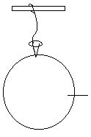

………………………………………………………

1. Name **one** example of living things in the environment.

……………………………………………………………………………………………………………………...………

1. Draw a shadow of a ball below.



1. State **one** example of a domestic animal kept for milk production.

……………………………………………………………………………………………………………………...………

1. Why do people keep cats at home?

……………………………………………………………………………………………………………………...………

1. Give any **one** example of common accidents at school.

……………………………………………………………………………………………………………………...………

1. Identify any **one** type of water.

……………………………………………………………………………………………………………………...………

1. Which body part helps us to see?

……………………………………………………………………………………………………………………...………

1. Give **one** method of soil formation.

……………………………………………………………………………………………………………………...………

1. Give any **one** example of edible seed.

……………………………………………………………………………………………………………………...………

1. Which type of soil is best for crop growing?

……………………………………………………………………………………………………………………...………

1. Identify **one** member of an extended family.

……………………………………………………………………………………………………………………...………

1. Give an example of crops grown in swamps.

……………………………………………………………………………………………………………………...………

1. Which cloud gives us rain?

……………………………………………………………………………………………………………………...………

1. Which diseases is spread by the female anopheles mosquito to man?

……………………………………………………………………………………………………………………...………

1. Draw **one** crop we eat its roots.
2. State any **one** material used for building houses.

……………………………………………………………………………………………………………………...………

1. Give **one** importance of shadows to people.

……………………………………………………………………………………………………………………...………

1. Give the main natural source of light and heat in the environment.

……………………………………………………………………………………………………………………...………

1. Who heads a family?

……………………………………………………………………………………………………………………...………

1. Name the type of soil with rough and large particles.

……………………………………………………………………………………………………………………...………

1. Give the breathing organs for an insect.

……………………………………………………………………………………………………………………...………

1. How is humus formed?

……………………………………………………………………………………………………………………...………

1. Which season is best for planting?

……………………………………………………………………………………………………………………...………

1. Give **one** example of an item made from the skin.

……………………………………………………………………………………………………………………...………

1. What is the role of children at home?

……………………………………………………………………………………………………………………...………

1. Name the darkest part of a shadow.

……………………………………………………………………………………………………………………...………

1. Why do people plant trees at home?

……………………………………………………………………………………………………………………...………

1. Name **one** example of a useful insect.

……………………………………………………………………………………………………………………...………

1. Which term is used to mean the surrounding of man?

………………………………………………………………………………………………………………………………………………………………………………………………………….…………………………………………………...………

1. Write the scientific name given to a young plant?

……………………………………………………………………………………………………………………...………

1. Give **one** game played with the help of wind.

……………………………………………………………………………………………………………………...………

1. Mention **one** immunisable disease.

……………………………………………………………………………………………………………………...………

1. What is germination?

………………………………………………………………………………………………………………………………………………………………………………………………………………………………………………………………...………

1. State the personal hygiene activity done by the help of a sponge.

……………………………………………………………………………………………………………………...………

**SECTION B (60 MARKS)**

1. a) How do we call a mixture of gases?

…………………………………………………………………………………………………………………………...……

1. Name any **two** components of air.
2. ……………………………………………………………………………………………………………………
3. ……………………………………………………………………………………………………………………
4. Identify any **one** use of air in the environment.

…………………………………………………………………………………………………………………………...…

1. a) Apart from father, name any other **one** member of a nuclear family.

…………………………………………………………………………………………………………………………...………

1. Write down **one** role of children in a family.

…………………………………………………………………………………………………………………………...…

1. Give **two** basic needs of man.
2. ……………………………………………………………………………………………………………………
3. ………………………………………………………………………………………………………………
4. a) What are domestic animals?

…………………………………………………………………………………………………………………………...………

…………………………………………………………………………………………………………………………...………

1. Give any **two** examples of domestic animals.
2. ……………………………………………………………………………………………………………………
3. ……………………………………………………………………………………………………………………
4. Write down any **one** way of caring for domestic animals?

…………………………………………………………………………………………………………………………...…

1. **Match list A to B.**

**List A List B**

Tongue feeling

Nose hearing

Ear tasting

Skin smelling

**Use the diagram of the soil profile and answer the question 45.**

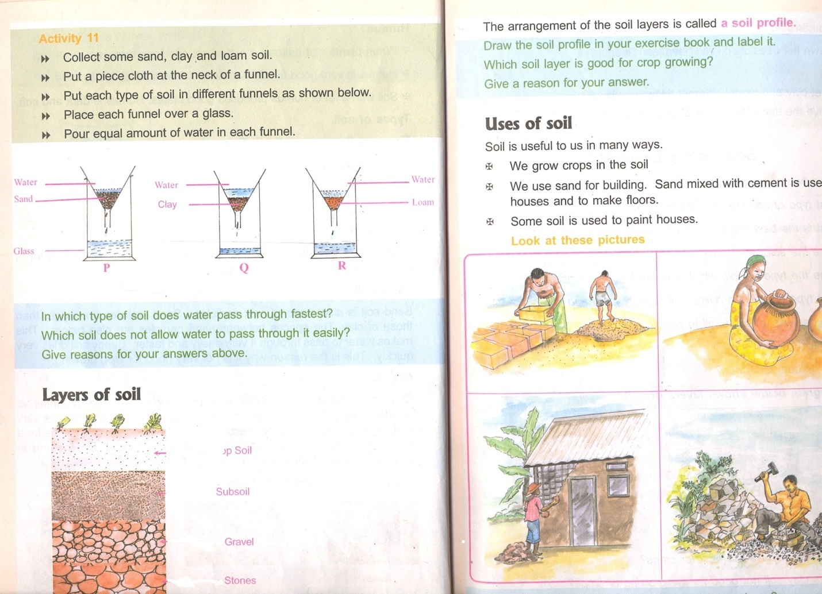

A

B

C

1. a) Name the layers marked

A: ………………………………………………………………………………………………………………………….

C: ………………………………………………………………………………………………………………………….

1. Why is layer **A** best for plant growth?

…………………………………………………………………………………………………………………………...…

1. Give **one** component of soil.

…………………………………………………………………………………………………………………………...…

1. a) Identify any **two** types of weather.
2. ………………………………………………………………………………………………………………………….
3. ..……………………………………………………………………………………………………………..…………
4. Give any **two** elements of weather.
5. ……………………………………………………………………………………………………………………
6. ……...……………………………………………………………………………………………………………
7. Give any **one** activity done in rainy season.

…………………………………………………………………………………………………………………………...…

1. 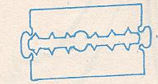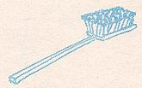**Name these things used to promote personal hygiene.**

…………………………………..…………… …………………………………………...…



………………………………………………. …………………………………………………

1. a) What is wind?

…………………………………………………………………………………………………………………………...……………………………………………………………………………………………………………………………………...…

1. State any **two** uses of wind in the environment.
2. ……………………………………………………………………………………………………………………
3. ……...……………………………………………………………………………………………………………
4. How is wind dangerous in the environment?

…………………………………………………………………………………………………………………………...…

1. What is food?

…………………………………………………………………………………………………………………………...……………………………………………………………………………………………………………………………………...…

1. Give any **one** source of food in the environment.

…………………………………………………………………………………………………………………………...…

1. State any **two** uses of food to the body.
2. ……………………………………………………………………………………………………………………
3. ……...……………………………………………………………………………………………………………
4. What is First Aid?

…………………………………………………………………………………………………………………………...……………………………………………………………………………………………………………………………...…………

1. List down **two** items found in the first Aid box.
2. ……………………………………………………………………………………………………………………
3. ……...……………………………………………………………………………………………………………
4. State **one** reason we give First Aid.

…………………………………………………………………………………………………………………………...…

1. a) What are wild animals?

…………………………………………………………………………………………………………………………...……………………………………………………………………………………………………………………………...………..

1. Give **three** examples of wild animals.
2. ……………………………………………………………………………………………………………………
3. ……...……………………………………………………………………………………………………………
4. ………………...…………………………………………………………………………………………………
5. **Complete the table below.**

|  |  |
| --- | --- |
| **Animal** | **Meat** |
| __________________ | Fillet |
| Sheep | ____________________ |
| ________________________ | Beef |
| Pig | ____________________ |

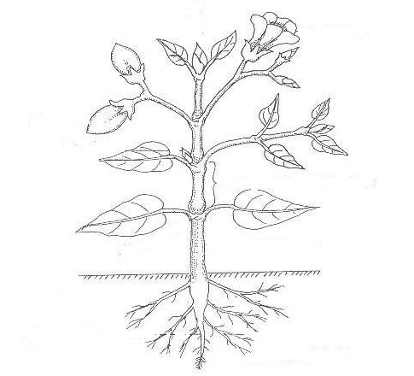**Study these diagram of a plant an answer question 53.**

A

C

B

D

1. a) Name the parts marked.
2. A: …………………………………………………………………………………………………………………..
3. C: ……………………………………………………………………………………………………………………..
4. Give any **one** use of part D to a plant.

……………………………………………………………………………………………………………………………….

1. State **one** way famers care for crops.

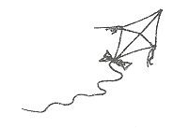……………………………………………………………………………………………………………………………….

1. 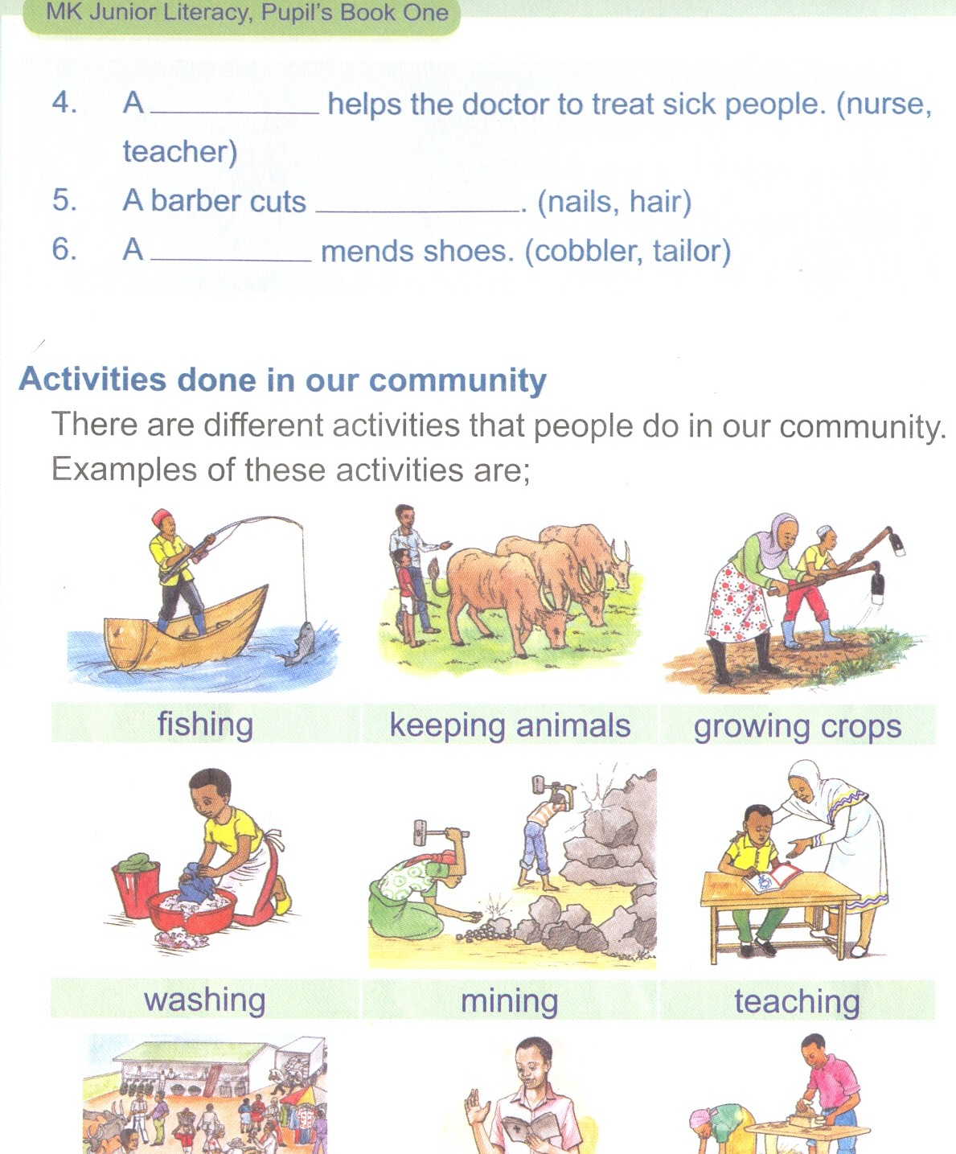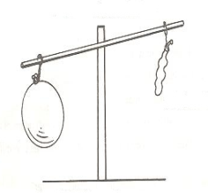a) Identify the properties of air shown below.

……………………………………………………… ……………………………………………..

1. Give **two** ways air is important in the environment.
2. ……………………………………………………………………………………………………………………
3. …………………………………………………………………………………………………………………….

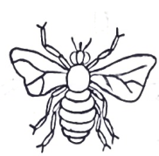**The diagram below is of an insect, use it to answer questions that follow.**

a

b

c

d

1. a) Name the parts marked;
2. b: ……………………………………………………………………………………………………………….
3. c: ……………………………………………………………………………………………………………..
4. Give the importance of part marked
5. a: ………………………………………………………………………………………………………………
6. d: ………………………………………………………………………………………………………………

**END**

**HARSHTON JUNIOR SCHOOL – MBALE**

**TERM ONE HOLIDAY PACKAGE-2023**

**PRIMARY THREE ENGLISH**

**Pupil’s Name: ……………………………………………………….**

**Read the following instructions carefully:**

1. This paper has two sections A and B

Section A has 40 questions and section B has 15 questions.

1. All working must be done using a blue or black ball point pen or ink. Any work done in pencil other than graphs and diagrams will **not** be marked.
2. Unnecessary changes of work may lead to **loss** of marks.
3. Any **handwriting** that cannot easily be read may lead to loss of marks.
4. Do not fill anything in the boxes indicated: “**For examiners’ Use only”** and those inside the questions paper.

|  |  |  |
| --- | --- | --- |
| **Qn. No.** | **MARKS** | **EXRS No.** |
| **1 – 10** |  |  |
| **11 – 20** |  |  |
| **21 – 30** |  |  |
| **31 – 40** |  |  |
| **41 – 50** |  |  |
| **51 - 52** |  |  |
| **53- 54** |  |  |
| **55** |  |  |
| **TOTAL** |  |  |

**Turn over**

**SECTION A**

**Fill in the missing letters:**

1. Pol_____ceman 4. D_____ctor
2. T____acher 5. H____spital
3. t____ble

**Use the correct form of words in the brackets to complete the sentences:**

1. Sandra is………………………………………………….…..the class room now**.(sweep)**
2. Aunt Rose ………………………………………………..………….food every day**.(cook )**
3. My father has ………………………………….………………home early today**.(come)**
4. Our hen has laid two ……………………………………………….……………………… **(egg)**
5. I am ……………………………………………………………to church for prayers. **(go)**

**Fill in the blank spaces with the correct form of words .**

1. Hannah……………………………………………………………….……….. playing netball now.
2. They ………………………………………………………….………….. washing their clothes.
3. The bird is ………………………………………………………………..……………….the nest.
4. Peter goes to school ……………………………………………..………………………foot.

**Use “has” or “have” to fill in the gaps correctly**

1. I …………………………………………………………………………..………….not eaten food.
2. Martha …………………………………………………..……………..not yet gone to school.
3. Mammy and daddy ……………………………………………………..bought a new car.
4. We …………………………………………….………… lost the money for buying food.

**Arrange the words in alphabetical order**.

1. ewe, doe, sow , calf

………………………………………………………………………………………………………………………………………….

1. coat, curtain , car chair

………………………………………………………………………………………………………..……………………………….

**Give one word for the underlined group of words.**

1. My sister bought a hen from the **person who grows crops and keeps animals.**

……………………………………………………………………………………………………………….………………………

1. All the **young pigs** have died.

……………………………………………………………………………………………………………………………………

1. Tim’s uncle is a **man who flies aeroplanes.**

………………………………………………………………………………………………………………………………………

1. She was given a **group of flowers** on her birth day.

………………………………………………………………………………………………………………….…………………..

**Give their plural form.**

1. bench ………………………..……………….. 27. girl ………………………………………………..
2. baby …………………………………….………. 28. box …………………………….………………..

**Use “a” or “an” to fill in the gaps correctly.**

1. …………………………………………………………..…. elephant and a lion are wild animals.
2. Daddy has bought ………………………………………………………………….……….. umbrella.
3. We have ……………………………………………………………..……….………. new car at home.
4. The doctor told me to eat ………………………………………………….apple every day.
5. I saw ………………………………………………………………big snake on my way to school.

**Use “is” or “are” to fill in the gaps correctly.**

1. There ……………………………………………………………………………a cup on that table.
2. Most of the pupils …………………………………………………………….. absent today.
3. Maria ……………………………………………………………………………..……… cooking food.
4. The bride …………………………………………………………….………………….. very smart .

**Underline the odd word out.**

1. Sunday, Tuesday , June , Friday .

……………………………………………………………………………………………………………………………………………

1. read , green , yellow , blue.

……………………………………………………………………………………….………………………………………………….

1. pen ,pencil , stone ,book .

……………………………………………….………………………………………………………………………………………..

1. hen , turkey, frog, duck .

…………………………………………….…………………………………………………………………………………………..

1. piglet , goat, chick ,kitten .

…………………………………………………………………………………….……………………………………………………

1. cake , juice , biscuit , bread .

…………………………………………………………………………………….………………………………………………….

1. desk ,bench , table , cup . …………………………………………………………………………………………………………………………………..

**Rewrite the given sentences as instructed in the brackets.**

1. Honey is sweet .Lemons are so bitter. **(Use:…………but …………..)**

…………………………………………………………………………………………………………….……………………

1. This is a pencil. **(Begin: These …………………….)**

………………………………………………………………………..…………………………………………………………

1. Martha is beautiful .Joan is beautiful. **(Use :…… and ………….)**

………………………………………………………………….………………………………………………………………

1. I did not go to school. I was sick. **(Use:………because ………………)**

…………………………………………………….……………………………………………………………………………

1. As sweet as …………………………………..**( complete correctly )**

…………………………………………………………………………………………………………………………………

1. That is the man. He lost my money. **(Use: …………who ………)**

………………………………………………………………………………………………………………………………

**SECTION B**

1. **Read the story below carefully and answer the given questions in full.**

**AT THE ZOO**

Our class visited the Zoo last Friday .A Zoo is a place where wild animals are kept .Animals are kept in cages and strong fences .We saw big and small animals e.g. Zebras ,lions . The peacock was the most beautiful bird I saw. It was the most interesting tour we have ever had.

**By Joel.**

**Questions**

1. Write the title of the story.

……………………………………………………………………………………………………………

1. Which was the most beautiful bird in the zoo?

………………………………………………………………………………………………………….

1. List **two** animals found in the zoo.

i) ………………………………………….. ii) …………………………………………………..

1. When did your class visit the zoo?

……………………………………………………………………………………………………………

1. Give the plural form of ;

a) class ……………………….…… b ) story …………………… c) lion………………………….

1. What is a zoo?

…………………………………………………………………………………………………..………………………….

1. Who wrote the story?

………………………………………………………………………………………….…………………………………….

1. **a) Match the following words to their opposites .**

**Word opposite**

bull monitress

tiger bitch

dog tigress

man cow

monitor woman

1. bull …………………………………………………………………………………………………………………………
2. tiger ………………………………………………………………………………………….……………………………
3. dog …………………………………………………………………………………..…………………………………….
4. man …………………………………………………………………………………………………….…………………
5. monitor……………………………………………………………………………..…………….…………………...

**b) Match and write the following people to their work places .**

cook office

policeman barber’s

teacher kitchen

barber police station

secretary school

1. Cook ………………………………………………………………………………………….…………………
2. Policeman …………………………………………………………………………………..…………………
3. Teacher…………………………………………………………………………………………………………
4. Barber…………………………………………………………….…………………………………………….
5. Secretary………………………………………………………………………………………………………
6. **a) Read the rhyme and answer the questions about it in full sentences .**

**A FARM**

Old Donald had a farm

Iya iya oo

And on his farm there were some cows

Iya iya oo

There was moo moo here

And moo moo there

**By Ntabazi**

**Questions:**

1. What is the rhyme about?

………………………………………………………………………………………………

1. Who had a farm?

……………………………………………………………………………………………..

1. What was on the farm?

………………………………………………………………………………………………

1. Write the sound that was made by the animals on the farm.

………………………………………………………………………………………………

1. What name is given to a young one of a cow?

……………………………………………………………………………………………..

**B: Make five correct sentences from the table**.

|  |  |  |
| --- | --- | --- |
| Mary  We  He  Joseph  They | is  are | in primary three.  playing football now.  going to the field.  revising our books. |

a)………………………………………………………………………………………………………..

b)………………………………………………………………………………………………………..

c)…………………………………………………………………………………………………………

d)…………………………………………………………………………………………………………

e)…………………………………………………………………………………………………………

1. **a) Complete the table below correctly.**

|  |  |  |
| --- | --- | --- |
| eat  jump  sweep | Eating  _______________  Cooking  Sweeping  _______________ | Ate  Jumped  cooked  ________________  walked |

**b) Use the words below to construct good sentences .**

1. Teacher …………………………………………………………………………………
2. Sleeping ………………………………………………………………………………..
3. Cut ………………………………………………………………………………………..
4. Clean …………………………………………………………………………………….
5. Doctor……………………………………………………………………………………
6. **a) Re-arrange these sentences to make a good story .**
   * 1. She is in P.3 class.
     2. Every day, she wakes up at 6:00 am.
     3. Annet is a very beautiful girl.
     4. Then she brushes her teeth.
     5. After brushing, she has her breakfast and rushes to school.

**A good story**

1. ……………………………………………………………………………………………………………..
2. …………………………………………….……………………………………………………………………..
3. …………………………………………………………………………………………………………………..
4. …………………………………………………………………………………………………………………..
5. …………………………………….……………………………………………………………………………..
6. **Use the words in the box to complete the story.**

boy , primary three , likes ,

because , lawyer

Okello is a very humble ………………… He is in ………………………class.

He …………………………………….……English so much. This is …………………..…………….

in English he gets good marks. His father wants him to become

…………………………………………………..………… in future when grows up

**HARSHTON JUNIOR SCHOOL – MBALE**

**PRIMARY THREE TERM ONE HOLIDAY PACKAGE**

**SOCIAL STUDIES 2023**

**DURATION: 2 HOURS 15 MINUTES.**

**Pupil’s Name: ……………………………………………………….**

**Read the following instructions carefully:**

1. This paper has two sections A and B

Section A has 40 questions and section B has 15 questions.

1. All working must be done using a blue or black ball point pen or ink. Any work done in pencil other than graphs and diagrams will **not** be marked.
2. Unnecessary changes of work may lead to **loss** of marks.
3. Any **handwriting** that cannot easily be read may lead to loss of marks.
4. Do not fill anything in the boxes indicated: “**For examiners’ Use only”** and those inside the questions paper.

|  |  |  |
| --- | --- | --- |
| **Qn. No.** | **MARKS** | **EXRS No.** |
| **1 – 10** |  |  |
| **11 – 20** |  |  |
| **21 – 30** |  |  |
| **31 – 40** |  |  |
| **41 – 50** |  |  |
| **51 - 52** |  |  |
| **53- 54** |  |  |
| **55** |  |  |
| **TOTAL** |  |  |

**Turn over**

**SECTION A (40 MARKS)**

1. Where do children go to learn?

……………………………………………………………………………………………………………………………

1. Write down **one** object used to keep water at home.

……………………………………………………………………………………………………………………………

1. What do children do to keep their classroom clean?

…………………………………………………………………………………….……………………………………

1. Why do people need water at home?

…………………………………………………………………………………..………………………………………

1. Give any **one** example of a domestic animal that gives milk.

……………………………………………………………………………………….……………………………………

1. Why do people keep domestic animals?

…………………………………………………………………………………….………………………………………

1. Which element f weather is a source of water?

………………………………………………………………………………………..…………………………………

1. Who heads the school?

……………………………………………………………………………………………………………………………

1. Write down **one** important place in your school

…………………………………………………………………………………….………………………………………

1. Give a reason why we need desks in our class

…………………………………………………………………………..………………………………………………

1. Why do school children wear uniform?

……………………………………………………………………………………………………………………………

1. 

Which object has been drawn above?

……………………………………………………………………………………………………………………………

1. Which **one** condition of weather makes people to use the above object?

……………………………………………………………………………………………………………………………

1. In which direction does the sun rise?

……………………………………………………………………………………………………………………………

1. In which one way do children show respect to their teachers?

……………………………………………………………………………………………………………………………

1. What is the work of school bursar?

……………………………………………………………..……………………………………………………………

1. Why is firewood needed at our school?

…………………………………………………………………………………………………………………………

1. How useful is a school bag to every child?

………………………………………………………………..…………………………………………………………

1. Name one place where people go for treatment when they are sick

……………………………………………………………………………………………………………………………

1. Which bird is found in the middle of the Uganda flag?

………………………………………………………………….………………………………………………………



1. What name is given to a person who makes the above item in the community?

……………………………………….……………………………………………………………………………………

1. How can we help our parents at home?

…………………………………………..………………………………………………………………………………

1. Which activity do pupils do during games and sports time?

……………………………………………………………………………………………………………………………

1. Mention at least **one** animal used for transport in our community.

…………………………………………………………..………………………………………………………………

1. Give a reason why farmers grow crops

…………………………………………………..………………………………………………………………………

1. In which **one** way can fish be preserved?

……………………………………………………………………………………………………………………………

1. Why does every community need police officers?

……………………………………………………………………………………………………………………………

1. How important is a father at home?

…………………………………..………………………………………………………………………………………

1. Which one is the capital city of Uganda?

…………………….………………..…………………………………………………………………………………

1. How useful is a well to the people?

………………………….…………………..…………………………………………………………………………

1. Why does Harshton Junior School need a bus?

…………………………….……………………………………………………………………………………………

1. Which domestic animal is used to provide security?

…………………………..…………………………………………………..…………………………………………

1. In which division of Mbale is your school located?

………………………….………………………………………………………….……………………………………

1. How useful is a fence in the compound?

…………………………………………………………………………………………………………………………

1. Which school do you go to?

………………………….………………………………………………………………………………………………

**For questions 36-40, answer either Christian question or Islamic questions but not both**

1. **EITHER:** Who created the earth?

…………………………………………………………………………………………………

**OR:** Who created the earth?

…………………………………………………………………………………………………

1. **EITHER:** What did God create to give us light during day?

…………………………………………………………………………………………………

**OR:** What did ALLAH create to give us light during night?

…………………………………………………………………………………………………

1. **EITHER:** How useful is Sunday to Christians.

…………………………………………………………………………………………………

**OR:** How is useful is Friday to Muslims?

…………………………………………………………………………………………………

1. **EITHER:** Who leads prayers in church?

…………………………………………………………………………………………………

**OR:** Who leads prayer in the Mosque?

…………………………………………………………………………………………………

1. **FOR BOTH**

**In the space provided below, draw a bible or Quran.**

**SECTION B**

1. Study the diagram below and use it to answer the following questions.

**N**

**1**

**2**

1. Name diagram drawn above

…………………………………………………………………………..……………………………………………

1. Name the compass direction marked;
2. 1……………………………………….. ii 2…………………………..………………………
3. Apart from a computer direction, give any other element of a good map?

………………………………………………………………………………………………………………………

1. In the spaces provided below, draw the following

|  |  |
| --- | --- |
|  |  |
| A map of a tree | A picture of a tree |

b. what do the following map symbols represent?

1. a. In which division is your school found?

……………………………………………………………………………………………………………………………

* 1. Mention any **one** important place near your school.

……………………………………………………………………………………….…………………………

* 1. Write down any **two** places where people go to buy food.

1. ……………………………………………………………………………………………………………
2. …………………………………………………………………………..………………………………
3. a. study the diagram below and answer questions.

**a**

**b**

**c**

1. What name is given t the above diagram?

………………………………………………………………………………………………………………………

1. Name the lights marked;

i. a……………………………………………………………………………………………………….………..

ii. b. ………………………………………………………………………………………………………………

1. Which light tells drivers to get ready?

…………………………………………………….…………………………………………………………………

1. a. Match the following people to their places of work correctly

|  |  |  |
| --- | --- | --- |
|  | **People** | **Place of work** |
| i) | Teacher | Police station |
| ii) | Doctor | Bank |
| iii) | Policeman | School |
| iv) | Banker | Hospital |

1. a) What is a home?

……………………………………………………………………………………………………………………………

1. Where do the following animals live?
2. Fish: ……………………………………………………………………………………………………………
3. Monkey: …………………………………………………………………………………………………….
4. How can we keep our homes clean?

……………………………………..………………………………………………………………………………

1. a). Give any **two** types of transport you know
2. …………………………………………………………………………………………………………………
3. …………………………….…………………………………………………………………………………
4. Mention any **two** means of transport
5. …………………………………………………………………………………………………………………
6. …………………………………….……………………………………………………………………………
7. a) Identify the **two** means of seasons
8. …………………………………………………………………………………………………………………
9. ………………………………………………………………..…………………………………………………
10. How are nimbus clouds useful to crops farmers?

…………………………………….……………………………………………………………………………………

1. In which **one** way do we use rain water?

…………………………………………………………………………………………………………………………

1. a) What are basic needs?

………………………………………………………………………………………………………………………………………………………………………………………..……………………………………………………………

Give **three** examples of basic needs of children

1. …………………………………………………………………………………………………………………
2. …………………………………………………………………………………………………………………
3. ………………………..………………………………………………………………………………………
4. a) Name any **two** dangerous objects that can cause accidents at home.
5. …………………………………………………………………………………………………………………
6. ……………………………..…………………………………………………………………………………
7. In which **two** ways can children prevent common accidents at home?
8. …………………………………………………………………………………………………………………
9. …………………………………………………………………………………………………………………

**FOR QUESTIONS 51-55 ANSWER EITHER CHRISTIAN OR ISLAMIC QUESTION BUT NOT BOTH**

1. **EITHER:**

**In the space provided below, draw and name three symbols of Christianity**

|  |  |  |
| --- | --- | --- |
|  |  |  |
|  |  |  |

1. Where do Christians go for their prayers?

……………………………………………………………………………………………………………………….

**OR:**

* 1. **In the space below, draw and name three Muslim symbols**

|  |  |  |
| --- | --- | --- |
|  |  |  |
|  |  |  |

* 1. Where do Muslims go for prayers?

………………………………………………………………………………………………………………………

1. **EITHER:**
2. Write down any **three** Christian names
3. ……………………………………………………………………………………………………………
4. ……………………………………………………………………………………………………………
5. ……………………………………………………………………………………………………………..
6. Mention **one** activity done at church

………………………………………………………………………………………………………………………

**OR:**

1. Write down any **three** Muslim names
2. ……………..…………………………….………………………………………………………………
3. …………………….……………………………………………………………………………………
4. ……………………………………………………………..……………………………………………
5. Mention **one** activity done at the mosque

…………………………………………………………………………………………………………….

1. **EITHER:**

**Match the following correctly**

|  |  |
| --- | --- |
| **List A** | **List B** |
| Allah  Eve  Jesus  Abel | Saved us from our sins  Son of Adam and Eve  First man to be created  First woman to be created |

**OR.**

**Match the following correctly**

|  |  |
| --- | --- |
| **List** | **List B** |
| Allah  Prophet Mohammad  Quran  Friday | Holy book in Islam  Day Muslims go for Juma  Created the earth  A great prophet in Islam |

1. **FOR BOTH**
2. Write down **two** ways children show love to others
3. ………………………………………….…………………………………………………………………
4. ……………………………………………………………………………………………………………
5. Identify any **two** things children share at school
6. ……………………………..……………………………………………………………………………
7. ……………………………….……………………………………………………………………………
8. **EITHER:**
9. Which **three** animals did God create to give us food?
10. …………………………………………………… ii) ………………………………..………………….
11. ………………………………………………………………………………………………………………….
12. How can people care for the above animals?

……………………………………………………………………………………………………………………….

**OR**:

1. Which **three** animals did Allah create to give us food
2. ………………………………………………… ii) ……………………………………………………
3. ……………………………………………………………………………………………………………
4. How can we care for the above animals?

………………………………………………………………………………………………………………………

**END**